* If you use **STS**. You must have Lombok installed in your Eclipse by running lombok-xyz.jar
* Please Try the Following the Steps:
  1. Include pom in Maven .
  2. Exit/Shutdown STS
  3. Find lombok Jar in ~/.m2/repository/org/projectlombok/lombok/version.x
  4. From Command Prompt/Shell java -jar lombok-1.x.y.jar [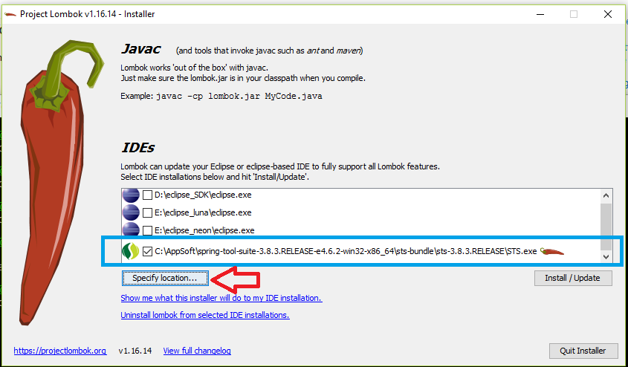](https://i.sstatic.net/pDcGm.png)
  5. Start STS

Thats all.

**EDIT**: I did this and was still showing errors, as mentioned in the comments. So I updated the project: *right-click on project -> Maven -> Update Project* and the errors disappeared.